**BATCH CREATION IN CLASSPLUS**

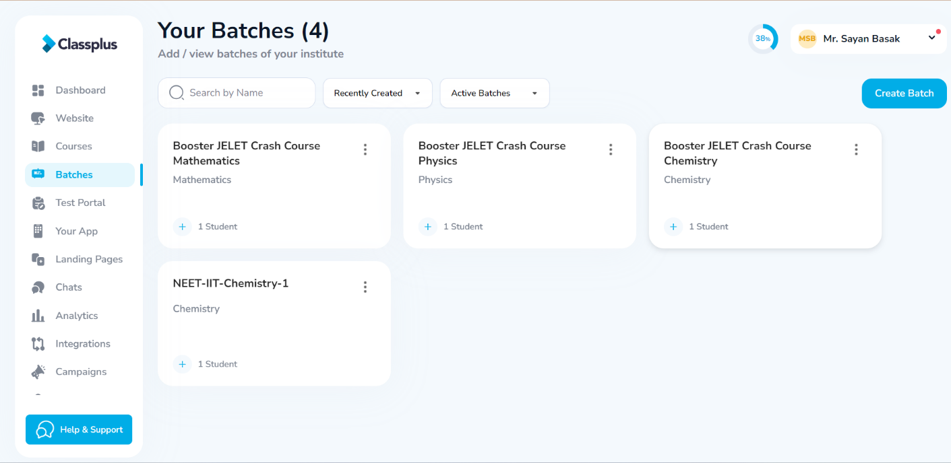

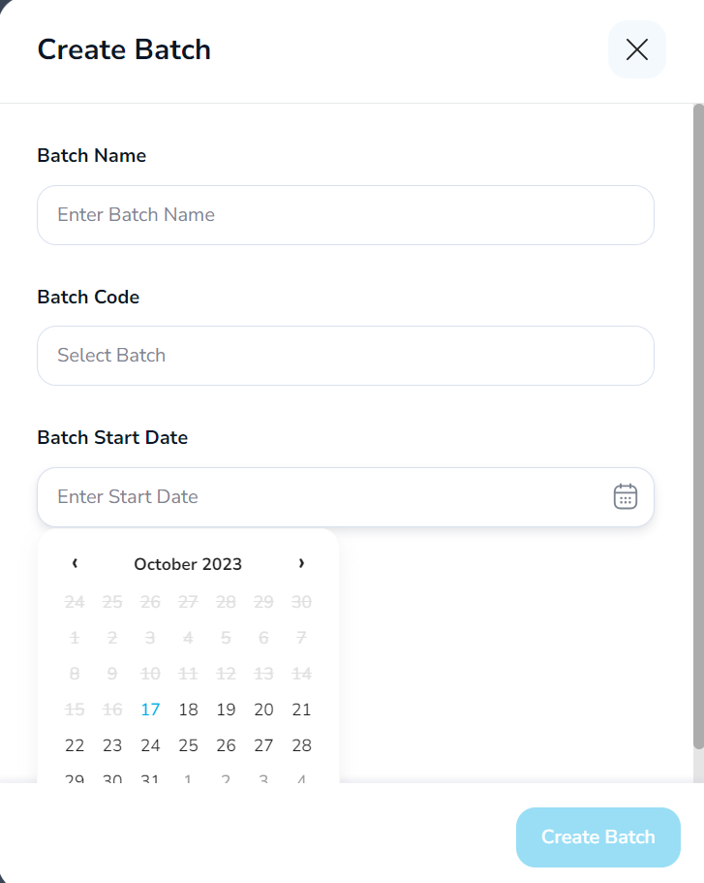

**DELETING BATCHES**

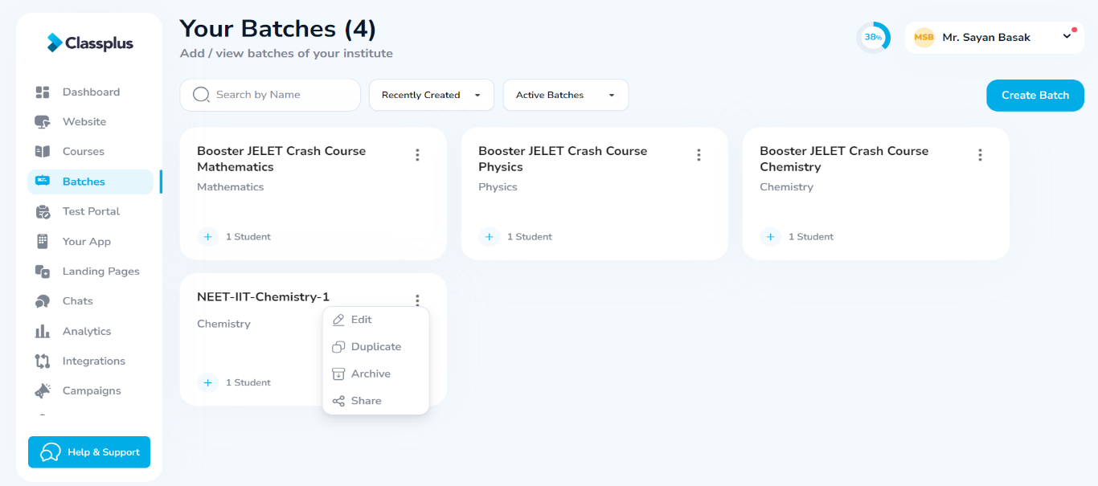

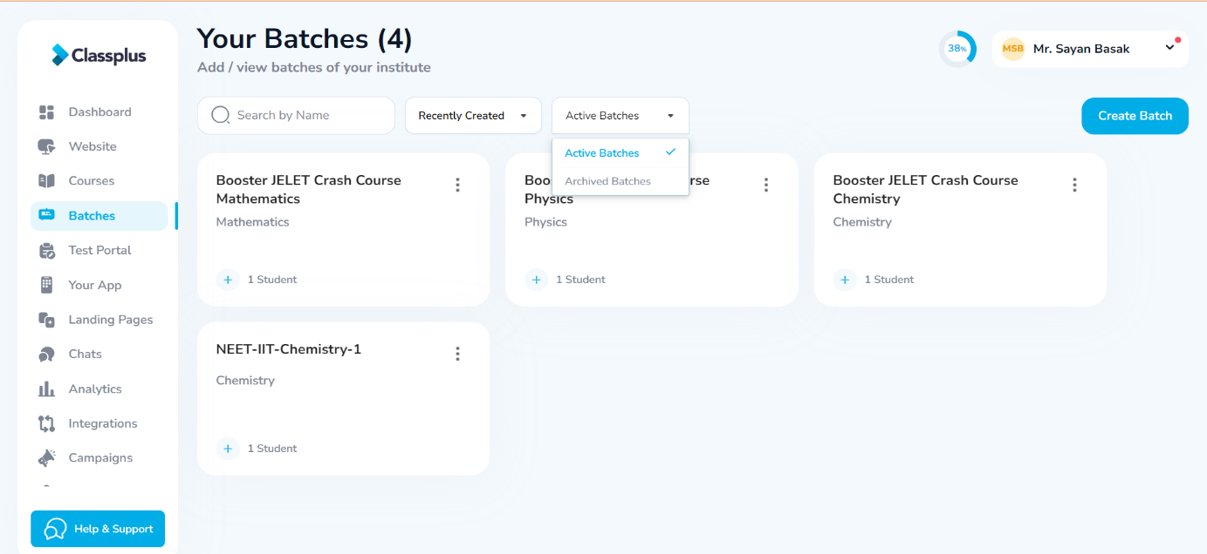

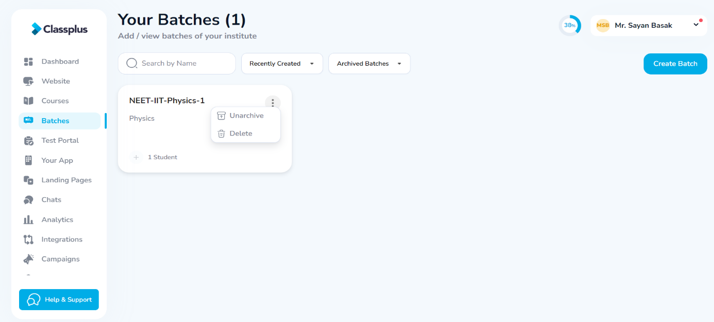

**N.B. – TO RESTORE AN ARCHIVED BATCH, CLICK ON UNARCHIVE**

**CREATING BATCH CLASSES**

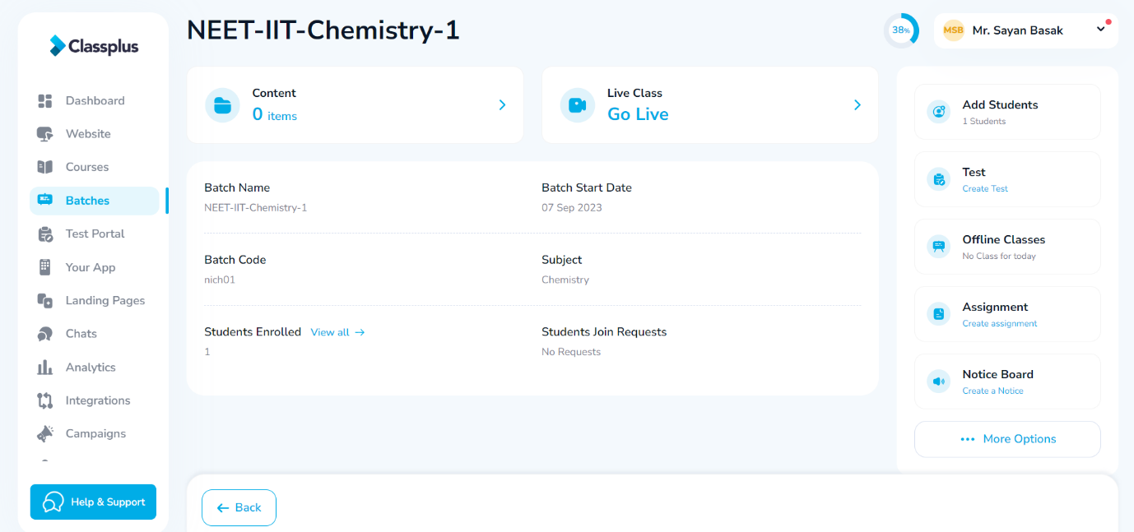

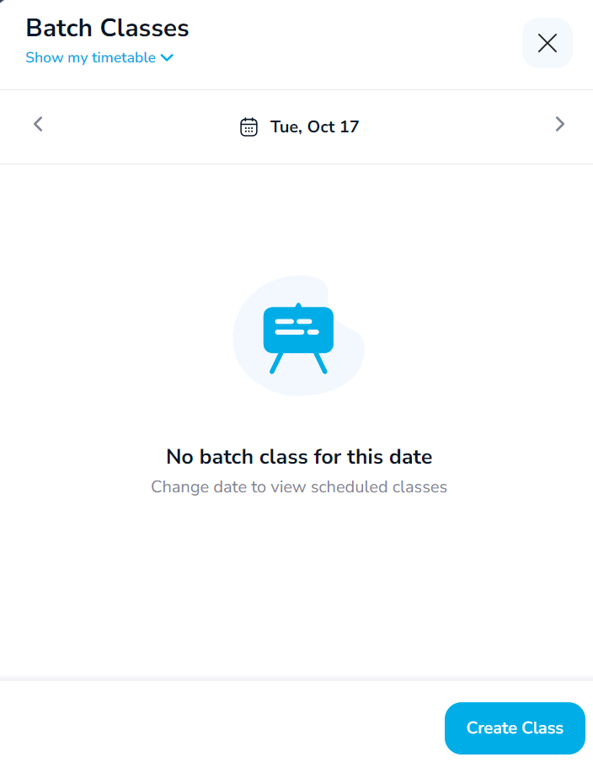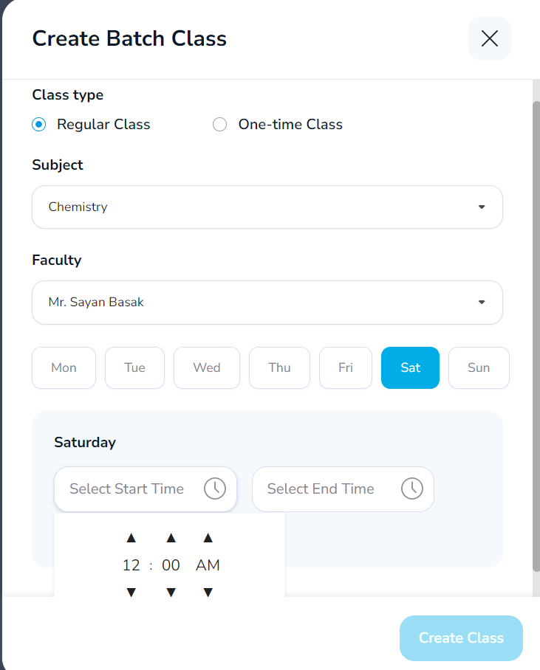

**TOGGLE TO SHOW ORG TIMETABLE TO VIEW SCHEDULED CLASSES**